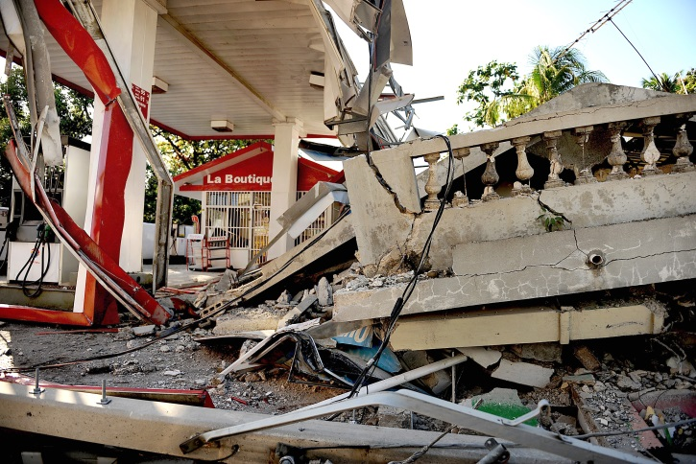
Deadly Earthquakes!

There have been many deadly earthquakes throughout recorded history. Earthquakes are one of the most feared natural disasters because they are difficult to prepare for and predict. Scientists are able to measure the magnitude of earthquakes and take an inventory of the damage done by each event. The devastation caused by an earthquake can be tremendous. It can take many years to rebuild and recover from such a disaster. In this assessment you are going to investigate whether there is a correlation (relationship) between earthquake magnitude and resulting devastation.

The United States Geological Survey maintains the website listed below. This site contains earthquake data categorized by the date of the earthquake, the location of the event, the number of human deaths, the magnitude of the earthquake, and informative comments about each earthquake. Choose an orange or red dot on the map and write down the important information from it including the year. Follow the directions for the assignment below the link.

Earthquakes with 1,000 or More Deaths Since 1900

Using the website above, choose ten earthquakes that occurred in consecutive order. It does not matter which time period you chose, as long at you are picking ten consecutive earthquakes. Using the data you have chosen, you will create a graph to see if there is a correlation between the magnitude of the ten earthquakes and the fatalities recorded. Using the website’s data and your graphed results, you will answer six conclusion questions.

Graphing Help:
You will create a scatter plot graph using Excel. If you are not familiar with scatter plots or Excel, there are three resources listed below.
- It will be helpful to read page 905 in your textbook for more information about creating scatter plot graphs using a data table.
- Click here for a website on creating a graph using Excel.
- Use the “How to” document linked to the Applied Knowledge Assessment part of the lesson text for step-by-step instructions on creating a graph.
Directions to Create your Graph:
- You will be comparing magnitude to fatalities. In Excel you should have one column for magnitude and one for fatalities.
- “Magnitude” will be on the x-axis (horizontal) and “Fatalities” will be on the y-axis (vertical) of your graph.
- Make sure your graph is titled and has labels on both the x and y-axis. An axis label should include a word or words describing the data shown and the unit that the data represents (meters, seconds, number, etc.).
- Remember to create/draw a trend line. For a good example of a trend line, click here.
To create a trend line, follow steps 7-9 in the “How to” document linked to the Applied Knowledge Assessment lesson text.
- Be sure to save your completed graph with your name included in the file extension. For example:
Earth_Science_Deadly_Earthquakes_Graph_JohnSmith

Directions for Answering the Conclusion Questions:
Once you have completed your scatter plot graph, answer the conclusion questions below. Type your answers to these questions in a Word document using the following guidelines:
- Your answers must be written in complete sentences with proper spelling, punctuation, and grammar.
- When typing your answers, use double spacing with one-inch margins and 12 point font.

Conclusion Questions:
- Based on the ten earthquakes you chose, do you think there was a correlation between earthquake magnitude and resulting fatalities?
- If you answered yes to the first question, describe the trend. If you answered no to the first question, explain your answer as it relates to your graph.
- Why do you think that your graph trend results are or are not the same as the overall earthquake results from the USGS?
- Looking at your graph, what can you infer about the correlation between magnitude and cost of damage resulting from the earthquakes?
- An outlier is any data point that is distant from the majority of the rest of the data. When using a trend line in a graph, an outlier would be a point far from the trend line. Were there any outliers in your graph? Give a reason for the outlier.
- If you do notice a correlation between magnitude and fatalities, can you conclude that one aspect causes the other? Explain why or why not.

Be sure to save your answers with your name included in the file extension. For example:
Earth_Science_Deadly_Earthquakes_Conclusions_JohnSmith

Directions for Submitting Your Applied Knowledge Assessment
For this Applied Knowledge Assessment, you will be submitting TWO documents for credit. Be sure to save them according the directions above.

Examples: Earth_Science_Deadly_Earthquakes_Graph_JohnSmith

Earth_Science_Deadly_Earthquakes_Conclusions_JohnSmith

After you have saved your documents, submit them to be graded for your Applied Knowledge Assessment.

